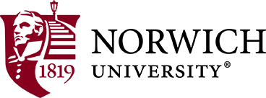
NU Club of Portsmouth/Seacoast
Golf Tournament

Every summer the NU Club of Portsmouth/Seacoast hosts a Student Sendoff. The 2018 event is scheduled on August 2nd at Breakfast Hill Golf Course in Greenland, NH. Last year we had a 9 hole scramble golf tournament prior to the sendoff. This year we have expanded the tournament to an 18 hole scramble that will begin at 12:00pm. Box lunches will be provided to everyone participating in the golf event at the beginning of the tournament.
The Student Sendoff will begin at 6:00pm in the Breakfast Hill Clubhouse and will include refreshments.
Choose one, two or all three from the following:
- _____ Check enclosed to support the Student Sendoff payable to the NU Club of Portsmouth/Seacoast.
- _____I have enclosed $25 to sponsor a tee or green for the golf scramble. Please use my name with graduation date or company as a sponsor (include a copy of a company logo for the sign)
_________________________________________
- I(we) would like to participate in the golf scramble @ $75 per person
Name_______________________________________
Name_______________________________________
Name_______________________________________
Name_______________________________________
Your name and email address______________________________
- Send this form with any checks payable to the NU Club of Portsmouth/Seacoast to Bob Bacon, 26 Brackett Rd, Portsmouth, NH 03801
Total
$_______ check to support Student Sendoff
$_______ Sponsor a tee or green for $25
$_______ Golfer #1 @ $75
$_______ Golfer #2 @ $75
$_______ Golfer #3 @ $75
$_______ Golfer #4 @ $75
$_______ Total enclosed

